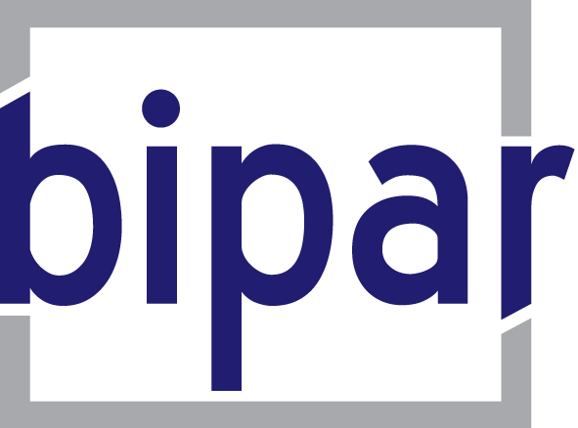
Avenue Albert-Elisabeth 40
B-1200 Bruxelles

Tel: +32/2/735 60 48
Fax: +32/2/732 14 18
bipar@skynet.be
www.bipar.eu

Glossary on European terms

Attachment to the letter of 30 June 2009 re
the interviews of K. Van Hulle and T. Kukal

Directive
A directive binds Member States as to the objectives to be achieved while leaving the national authorities the power to choose the form and the means to be used

IMD: Insurance Mediation Directive
The Directive on Insurance Mediation (2002/92/EC) was adopted on 9 December 2002 and EU Member States had until 15 January 2005 to implement the IMD text into national legislation. The two main objectives of the IMD are to enable insurance intermediaries to market their services in the EEA by way of freedom of services (FOS) or establishment (FOE) on the basis of their home country registration and to ensure a high level of consumer protection.

CEIOPS
The Committee of European Insurance and Occupational Pensions Supervisors (CEIOPS) is the Level 3 Committee for the insurance and occupational pensions sectors under the so called "Lamfalussy Process".

CEIOPS is composed of high level representatives from the insurance and occupational pensions supervisory authorities of the European Union Member States. The authorities of the other Member States of the European Economic Area (Norway, Iceland and Liechtenstein) and the European Commission participate in CEIOPS' activities as observers.

CEIOPS is involved in both Level 2 and 3 Lamfalussy activities by:
- providing advice to the European Commission on drafting of implementation measures for framework directives and regulations on insurance and occupational pensions ("Level 2 activities"), and
- issuing supervisory standards, recommendations and guidelines to enhance convergent and effective application of the regulations and to facilitate cooperation between national supervisors ("Level 3 activities")

Consequently, CEIOPS is currently:
- advising the Commission, either at the Commission's request or on the Committee's own initiative, in particular on the preparation of draft implementing measures in the fields of insurance, reinsurance and occupational pensions;
- contributing to the consistent implementation of EU Directives and to the convergence of Member States' supervisory practices throughout the Community;
- acting as a forum for supervisory co-operation, including the exchange of information on supervised institutions;
- dealing with convergence in the supervision of insurance companies and occupational pension funds.

Lamfalussy process

European Parliament
Council
European Commission, after consulting the EIOPC (European Insurance and Occupational Pensions Committee), requests advice from CEIOPS on technical implementing measures
CEIOPS prepares measures in consultation with market participants (including BIPAR), end-users and consumters, and submits them to European Commission
European Commission examines the measures and makes a proposal to the EIOPC
EIOPC votes on proposal
European Commission adopts measures
European Parliament

Kept fully informed and can adopt a Resolution if measures exceed implementing powers

CEIOPC works on recommendations, guidelines and standards (on areas not covered by EU legislation), peer review, and compares supervisory practices to enhance their convergence
European Commission checks Members States’ compliance with EU legislation
European Commission may take legal action against Members States suspected of breach of Community Law
Agreement on framework principles and definition of implementing powers in Directive/Regulation
L
E
V
E
L

1
European Commission adopts formal proposal for Directive/Regulation after a full consultation process (including advice from CEIOPS)

L
E
V
E
L

2
L
E
V
E
L

3
L
E
V
E
L

4

